 2023-2024

Sessional Test I–March, 2023

Set-C

Roll No: ……………… [Total No. of Pages: 2]

Programme: B.E Time: 90 minutes

Course Title: Computer Organization and Architecture

Course Code: CS157 Max. Marks: 40

General Instructions:
- Follow the instructions given in each section.
- Do not write anything on the question paper, except your roll no.
- Make sure that you attempt the questions in order.

Section - A

(Q 1 to 5: Each question carries 1 mark)
Q1. To store one-bit digital data which of the following can be used?
- NAND GATE
- NOR GATE
- Flip flop
- Register

Answer: Flip Flop

Q2. Which of the following register keeps track of the instructions stored in the program stored in memory?
- Accumulator
- Address Register
- Program Counter
- Index Register

Answer: Program Counter

Q3. The Logic circuit is given below, what could be the output?

- NOR
- NAND
- AND
- OR

Answer: NAND Gate


Q4. D flip flop can be made from a J-K flip flop by making?
- J = K = 1
- J = K = 0
- J = Complement of K
- J = K
Answer: J = Complement of K
Q5. An instruction cycle refers to:
- Fetching an instruction
- Executing an instruction
- Fetching an instruction, decoding it, reading the contents of the effective addresses of the operands and executing the instructions
- Clock cycle time
Answer: Fetching an instruction, decoding it, reading the contents of the effective addresses of the operands and executing the instructions

Section - B

(Q 6 to 10: Each question carries 3 marks)

Q6. Suggest a logic circuit to eliminate the race around condition in a JK flip-flop.

Answer

Race Around Condition in JK Flip-flop – For J-K flip-flop, if J=K=1, and if clk=1 for a long period of time, then Q output will toggle as long as CLK is high, which makes the output of the flip-flop unstable or uncertain. This problem is called race around condition in J-K flip-flop. This problem (Race Around Condition) can be avoided by ensuring that the clock input is at logic “1” only for a very short time. This introduced the concept of Master Slave JK flip flop.

Master Slave JK flip flop –
The Master-Slave Flip-Flop is basically a combination of two JK flip-flops connected together in a series configuration. Out of these, one acts as the “master” and the other as a “slave”. The output from the master flip flop is connected to the two inputs of the slave flip flop whose output is fed back to inputs of the master flip flop.

In addition to these two flip-flops, the circuit also includes an inverter. The inverter is connected to clock pulse in such a way that the inverted clock pulse is given to the slave flip-flop. In other words, if CP=0 for a master flip-flop, then CP=1 for a slave flip-flop and if CP=1 for master flip flop then it becomes 0 for slave flip flop.

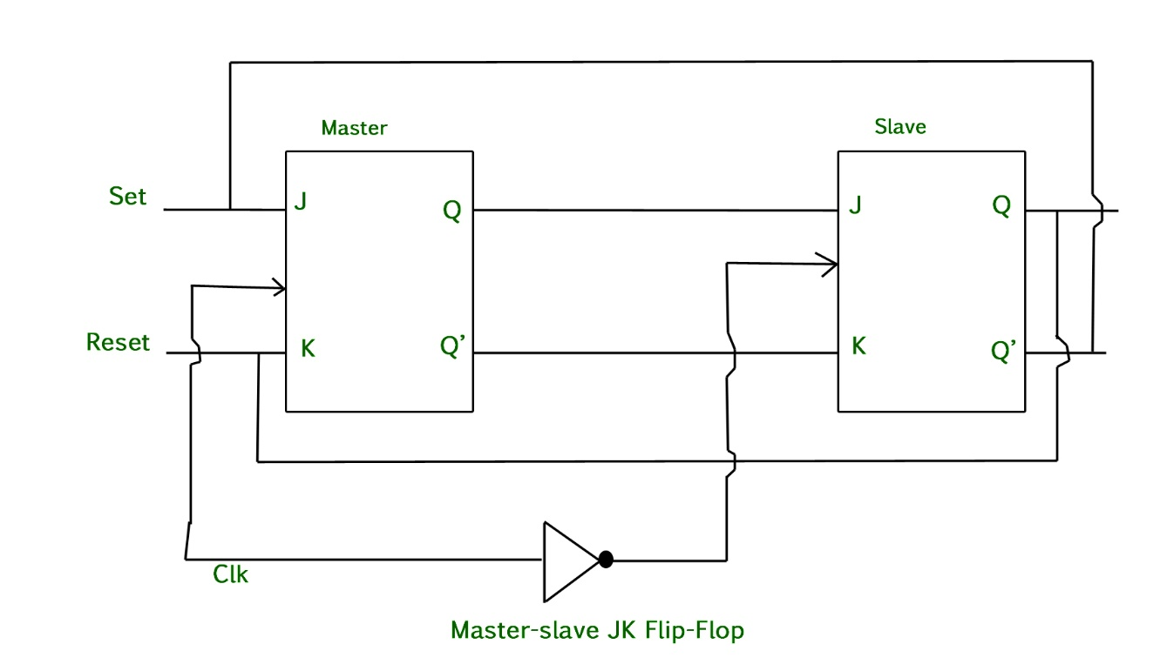

Working of a master slave flip flop –
- When the clock pulse goes to 1, the slave is isolated; J and K inputs may affect the state of the system. The slave flip-flop is isolated until the CP goes to 0. When the CP goes back to 0, information is passed from the master flip-flop to the slave and output is obtained.
- Firstly, the master flip flop is positive level triggered and the slave flip flop is negative level triggered, so the master responds before the slave.
- If J=0 and K=1, the high Q’ output of the master goes to the K input of the slave and the clock forces the slave to reset, thus the slave copies the master.
- If J=1 and K=0, the high Q output of the master goes to the J input of the slave and the Negative transition of the clock sets the slave, copying the master.
- If J=1 and K=1, it toggles on the positive transition of the clock and thus the slave toggles on the negative transition of the clock.
- If J=0 and K=0, the flip flop is disabled and Q remains unchanged.

Q7. Write the sequence of (Q_{1,} Q₀) for the counter circuit shown below:

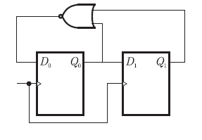

Answer: 00,01,10,00…

Q8. Illustrate the difference between serial and parallel transfer? Which transfer is faster one? Explain how to convert serial data to parallel.
There are two methods used for transferring data between computers which are given below: Serial Transmission and Parallel Transmission.
Serial Transmission:
In Serial Transmission, data-bit flows from one computer to another computer in bi-direction. In this transmission, one bit flows at one clock pulse. In Serial Transmission, 8 bits are transferred at a time having a start and stop bit.
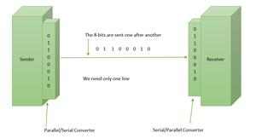
Serial Transmission
Parallel Transmission:
In Parallel Transmission, many bits are flow together simultaneously from one computer to another computer. Parallel Transmission is faster than serial transmission to transmit the bits. Parallel transmission is used for short distance.
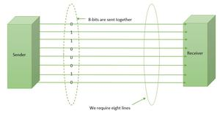
Parallel Transmission

Parallel Transmission is fast in comparison of Serial Transmission.

4-bit Serial-in to Parallel-out Shift Register

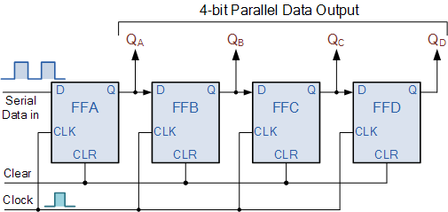

The operation is as follows. Lets assume that all the flip-flops (FFA to FFD ) have just been RESET ( CLEAR input ) and that all the outputs Q_{A} to Q_{D} are at logic level “0” ie, no parallel data output.

If a logic “1” is connected to the DATA input pin of FFA then on the first clock pulse the output of FFA and therefore the resulting Q_{A} will be set HIGH to logic “1” with all the other outputs still remaining LOW at logic “0”. Assume now that the DATA input pin of FFA has returned LOW again to logic “0” giving us one data pulse or 0-1-0.

The second clock pulse will change the output of FFA to logic “0” and the output of FFB and Q_{B} HIGH to logic “1” as its input D has the logic “1” level on it from Q_{A}. The logic “1” has now moved or been “shifted” one place along the register to the right as it is now at Q_{A}.

When the third clock pulse arrives this logic “1” value moves to the output of FFC (Q_{C}) and so on until the arrival of the fifth clock pulse which sets all the outputs Q_{A} to Q_{D} back again to logic level “0” because the input to FFA has remained constant at logic level “0”.

The effect of each clock pulse is to shift the data contents of each stage one place to the right, and this is shown in the following table until the complete data value of 0-0-0-1 is stored in the register. This data value can now be read directly from the outputs of Q_{A} to Q_{D}.

Then the data has been converted from a serial data input signal to a parallel data output.

Q9. How does computer handle the program interrupt? Explain using flow chart for the same.

- An alternative to the programmed controlled procedure is to let the external device inform the computer when it is ready for the transfer.
- In the meantime, computer can be busy with other tasks.
- This type of transfer uses the interrupt facility. While computer is running the program, it does not check the flags, however when a flag is set then computer receives an interrupt.
- The interrupt enable flip-flop IEN can be set and cleared with two instructions.
- When IEN is cleared to zero (with IOF instruction), the flag cannot interrupt the computer.
- When IEN is cleared to 1 (with ION instruction), the computer can be interrupted.

- Here the modified fetch and decode phase of interrupt cycles as follow:

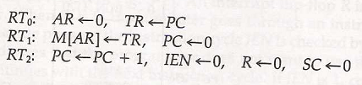
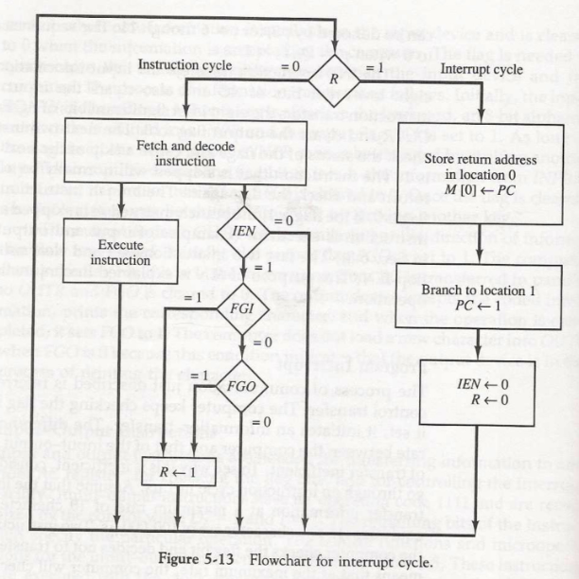
flowchart of interrupt cycle

Q10. A computer uses a memory unit with 65536 words of 32 bits each. A binary instruction code is stored in one word of memory. The instruction has four parts: an indirect bit, an operation code, a register code part to specify one of 1024 registers and an address part.
- How many bits are there in the operation code, the register part and the address part?
- Draw an instruction word format and indicate the number of bits in each part.

Memory size = 65536 words = 2^16

1-word size= 32 bits

1 instruction =1 word
- Register bits = 10 (as 1024 = 2^10)

Address bits = 16 (as 65536 = 2^16)

Indirect bit= 1 (given)

Operation code = 5 bits (32-(10+16+1))
- Instruction Format
01  (31) | 5-bits Opcode  (26 to 30 bits) | 10-bits Register Address  (16 to 25 bits) | 16-bits memory address  (0-15 bits)

Section – C

(Q 11 to 12: Each question carries 5 marks)

Q11. a) What is the difference between a direct and an indirect address instruction?

Direct Addressing Mode: In direct addressing mode, the address field in the instruction contains the effective address of the operand and no intermediate memory access is required.
Example: Add the content of accumulator and memory location 1001 and store back to Accumulator:
Add, (1001)
Here 1001 is the address where the operand is stored.
Indirect Addressing Mode: In Indirect addressing mode, the address field in the instruction contains the memory location or register where the effective address of the operand is present. It requires two memory access.
Example:
LOAD AC, 500
The above instruction is used to load the content of the memory location stored at memory location 0500 to Accumulator. In other words, we can say, effective address is stored at memory location 500.
- With the help of a diagram show how the effective address is found in both the cases.
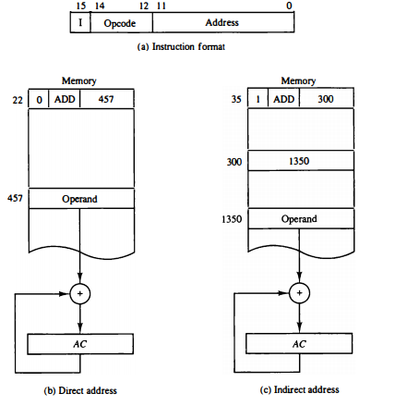
Q12. Design a MOD counter which will count up to 1001 and restart from 0000 when we give clear to T or J-K flip-flop.

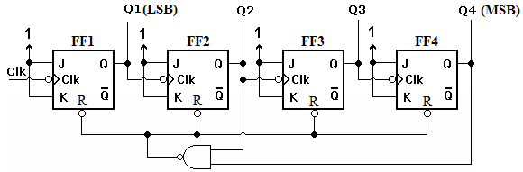

Section – D

(Q 13: Question carries 10 marks)
Q13. a) An instruction at address 021 in the basic computer has an address part equal to 083 (all numbers are in hexadecimal). The memory word at address 083 contains the operand A9E1 and the content of AC (Accumulator) is B567. Determine the contents of the registers at the end of the execute phase: PC (Program Counter), AR (Address Register), AC and IR (Instruction Register). Implement the problem using following operation codes (Hexadecimal code):
i) AND (0083)

ii) INC (7020)
Instruction | PC | AR | DR | AC | IR
AND(0083) | 022 | 083 | A9E1 | A161 | 0083
INC (7020) | 022 | -- | -- | B568 | 7020

b) To select the timing signal and opcode using decoder draw the control unit of basic computer. (6+4 = 10)

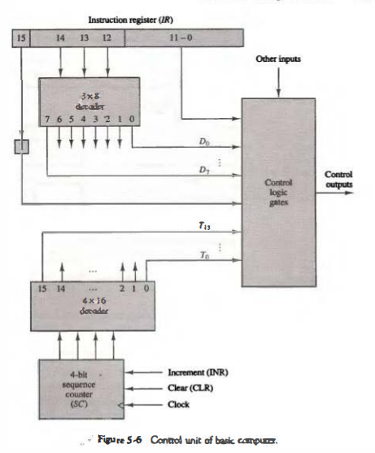

The instruction register is divided into three parts:
- the 1 bit,
- the operation code, and
- bits 0 through 11.
- The operation code in bits 12 through 14 are decoded with a 3 x 8 decoder. The eight outputs of the decoder are designated by the symbols D₀ through D₇. The subscripted decimal number is equivalent to the binary value of the corresponding operation code. Bit 15 of the instruction is transferred to a flip-flop designated by the symbol I. Bits 0 through 11 are applied to the control logic gates. The 4-bit sequence counter can count in binary from 0 through 15. The outputs of the counter are decoded into 16 timing signals T₀ through T₁₅.
- The sequence counter SC can be incremented or cleared synchronously. Most of the time, the counter is incremented to provide the sequence of timing signals out of the 4 x 16 decoder. Once in a while, the counter is cleared to 0, causing the next active timing signal to be T₀.
- As an example, consider the case where SC is incremented to provide timing signals T₀, T₁, T₂, T₃, and T₄ in sequence. At time T₄, SC is cleared to 0 if decoder output D₃ is active. This is expressed symbolically by the statement
- D₃T₄: SC <__ 0

